**Competitive analysis**

There are several sailing simulators that exist online.

**The Pirate King Sailing Simulator** (http://www.thepirateking.com/ships/sail_simulator.htm)

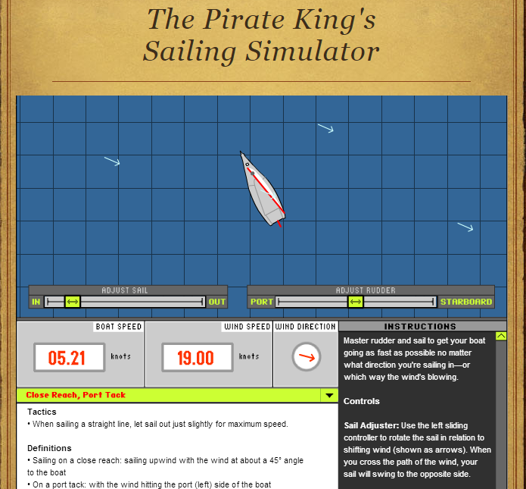

This is the most basic one that I found, teaching the user the bare essentials of sailing, which basically consists of controlling the movement of the boat and movement of the sail using the two sliders on the screen. It also tracks the boat speed and wind speed as the user makes these adjustments, allowing the user to see what the most optimal sail and corresponding rudder positions are as the user moves from one point to another.

It is a good idea to have the boat speed and wind speed shown on the screen. The user can easily understand the effect of each adjustment he makes to the sail and rudder and chose the best combination that will enable him to reach the goal faster.

However, it is too basic and it is understandable that a user will get bored after playing with this for a few minutes, since there is no specific aim or end-goal.

**SailX** ([www.sailx.com](http://www.sailx.com))

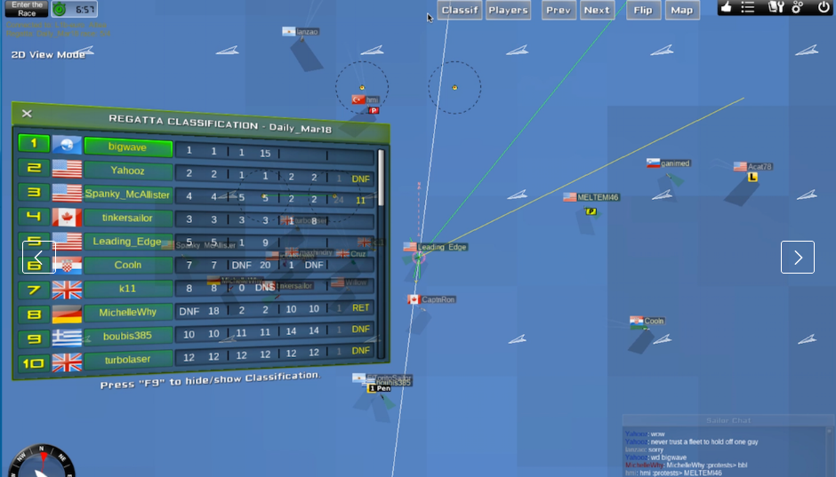

SailX touts itself as “the world’s best sailboat racing simulator”, and it is easy to see why. Users have their own accounts and are ranked with other players on the Internet according to their cumulative scores across multiple races.

There are 2D and 3D modes for users to select from, a live chat, forums, replays and different racing formats to choose from. Essentially, it has everything present in a real-life sailing race, except for the cold water splashing in your face and the need to clean and pack up afterwards.

However, there are three main drawbacks that I will highlight. Firstly the complete list of features are only available for $25 a year, which is considered as a high price to pay for a game to many people. While it is played on the web, specialized software has to be installed for the game to be run, bringing about a small degree of inconvenience. Most importantly, it is difficult for beginners to pick up the game, since there are only a condensed set of instructions and no tutorial. Starting the simulator immediately puts the user in a high-pressured, real-time game with other players from around the world, resulting in utter confusion.

For my version of the game, I will have a gentler introduction to sailing, possibly fusing the positive elements of the two case studies together. I could have a tutorial at the beginning featuring just the user’s boat, followed by an actual race with computer-generated players or live players from other computers.